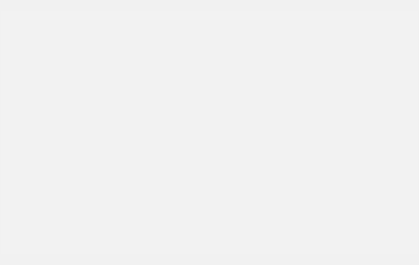

Contoso Electronics One Microsoft Way 123-456-7890

[http://www.contoso.com](http://www.contoso.com/)

Dear **Andre Lawson**,

This letter is to notify you that our contract with your company is nearing term or has expired. **Adatum Corporation** ([**http://www.adatum.com/**)](http://www.adatum.com/)) has provided valuable services to our insured members during the term of the existing contract.

According to our records, we have served approximately **7587** members with **VanArsdel, Ltd.** from the term of service start date of **Saturday, September 7, 2019**.

We would like to request a meeting to discuss fee schedule increases of **12** percent for the coming contractual term. As you are likely aware, our office has implemented several quality measures which we believe will result in improved care to your insured members and qualify for a discount:

* Implementation of more than **10** clinical performance measurements
* Patient satisfaction surveys for participants in the **Diamond** plan
* Improvements in **Technology**

Sincerely,

**Kerry Allen**

**Request for Additional Disclosure**

It appears that our office was not provided with the applicable fee schedule for 2020 related to this contract or the applicable internal procedures for bundling, coding and outlier application which affect reimbursement. Therefore, we request that this fee needs to be reduced by **11** percent.